Name - Gaurang A Raorane

Div - D15A Roll no - 49

Batch - C

Experiment - 1

**Aim -** Installation and Configuration of Flutter Environment.

**Pre Requisites**: Android Studio Hedgehog, Visual Studio Code and Flutter package.I highly recommend watching this video, for Setting up your Flutter Environment and your Virtual Device: https://youtu.be/ZSWfgxrxN0M?feature=shared

**Installation -**

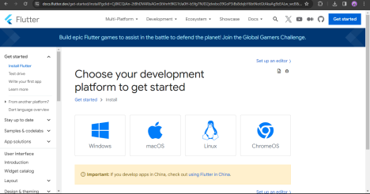

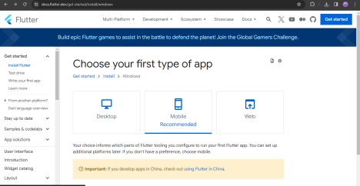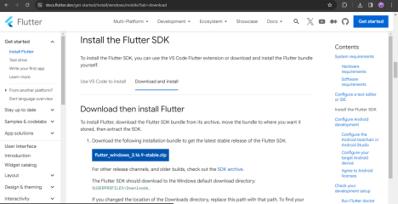Extract the files in the directory -

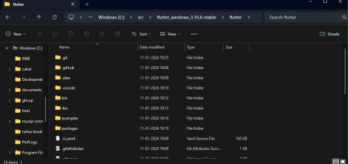Setup path in Environment variables -

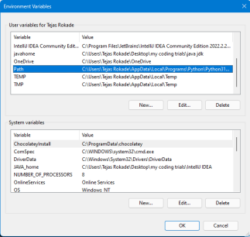

Create new variable and insert the path to bin folder and apply -

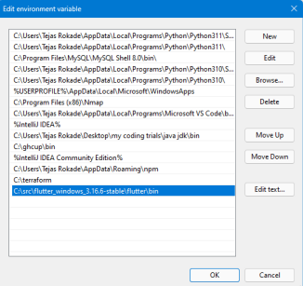

Then on CMD -

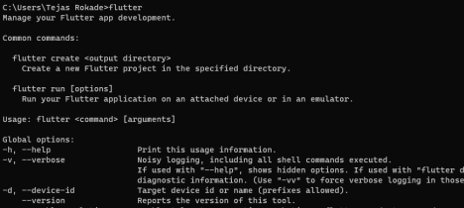

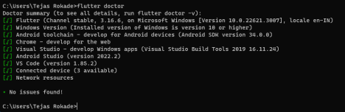The error for Android toolchain will occur if havent installed android SDK Command Line Tools in Android Studios SDK Tools.

And IF issue of android licenses occurs run Flutter –android-licenses command in the prompt and type y+enter till process is complete

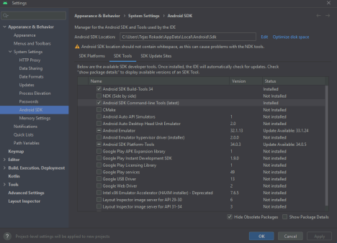

**Code -**

import 'package:flutter/material.dart';

void main() {

runApp(const MyApp());

}

class MyApp extends StatelessWidget {

const MyApp({Key? key}) : super(key: key);

@override

Widget build(BuildContext context) {

return MaterialApp(

title: 'Welcome to Flutter',

home: Scaffold(

appBar: AppBar(

title: const Text('Welcome to Flutter'),

),

body: const Center(

child: Text('Hello Tejas’'),

),

),

);

}

}

**Output -**

